**Lab Report**

Course Name : Electrical Circuits

Course Code : CSE209 LAB

Section No : 04

Experiment N : 04

Experiment name : Bias Point Detail Analysis of DC Circuit With Dependent Sources Using PSpice Schematics.

**Submitted to**

Course instructor : Rashedul Amin Tuhin

Senior lecturer

Computer science and engineering

**Submitted by**

Name: Apurba Roy Ajay

Student’s ID : 2018-3-60-063

Department : Computer science and engineering

**Date of report submission : /09/2020**

**Objectives:**

1. To analyze Bias Point Detail of DC circuit with Dependent Source using PSpice Schematics.

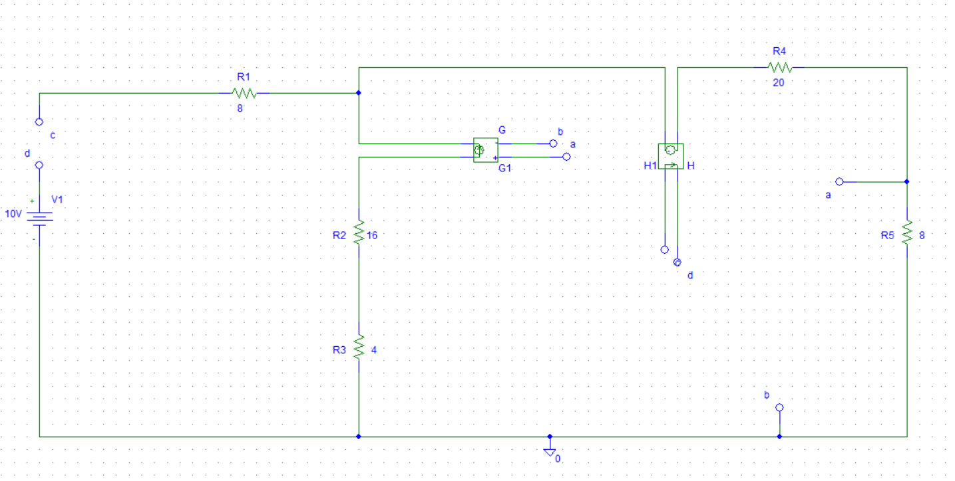

**Answer(s) to the Post-Lab Report:**

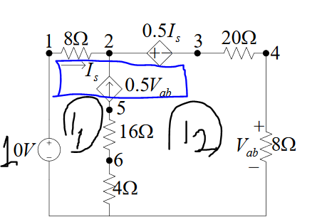

From the figure,

Is = i1

Vab = 8i2

KVL at Super-mesh,  
 -10 + 8 $i_{1}$ + 0.5 $I_{s}$ + 20 $i_{2}$ + 8 $i_{2}$ = 0  
 -10 + 8 $i_{1}$ + 0.5 $i_{1}$ + 20 $i_{2}$ + 8 $i_{2}$ = 0 [$∵I_{s} = i1$]  
 8.5 $i_{1}$ + 28 $i_{2}$ = 10 ----(1)

And,

- = 0.5Vab  
 - = 0.5 $×$ 8i2 [$∵Vab = 8i_{2}$] $i_{1}$ 
 +3 $i_{2}$ = 0 ---- (2)

Solving equation (1) and (2), we get,

$i_{1}$ = -12A, $i_{2}$ = 4A

So, $i_{0}$  
 = $i_{2}$– $i_{1}$ = 4 – (-12) = 4 + 12 = 16A  
Now, Voltage at Node 1, $V_{1}$ 
 = 10V

Voltage at Node 2,

KCL at Node 2,

- 16 + $\frac{V_{2}-0.5I_{s}}{28}$ = 0

- - 16 + $\frac{V_{2}}{28}$- $\frac{0.5×(-12)}{8}$ = 0 [$∵I_{s} = i_{1} =-12A$]

$\frac{9V_{2}}{56}$ = $\frac{477}{28}$

$∴$ $V_{2}$ = 106V

Voltage at Node 3,

$V_{3}$ = (4 $×$ 28) = 112V [$∵ i_{2} =4A and R=(20+8)Ω$]

Voltage at Node 4,

$V_{4}$ = + (4 $×$ 8) = 32V [$∵ i_{2} =4A and R=8Ω$]

Voltage at Node 5,

$V_{5}$ = - (16 $×$ 20) = -320V [$∵ i_{0} =16A and R=(16+4)Ω$]

Voltage at Point 6:

$V_{6}$ = - (16 $×$ 4) = -64V [$∵i_{0} =16A and R=4Ω$]

2.

Comparing the theoretical solution of the circuit obtained from above with the solution obtained from PSpice.

|  |  |  |
| --- | --- | --- |
|  | **PSpice** | **Calculated** |
|  | $i_{1}$ = 12A | $i_{1}$ = -12A |
| **Currents** | i2 = 4A | i2 = 4A |
|  | i0 = 16A | i0 = 16A |
|  | V1 = 10V | V1 = 10V |
|  | V2=106V | V2=106V |
| **Voltages** | V3=11V | V3=11V |
|  | V4=32V | V4=32V |
|  | V5 = -320V | V5 = -320V |
|  | V6 = -64V | V6 = -64V |

**Conclusion:**We connect this circuit using Pspice software.I think if we could do this same experiment in the lab, the measure value would change a little bit and most importantly we could learn how to connect the circuit for real life.